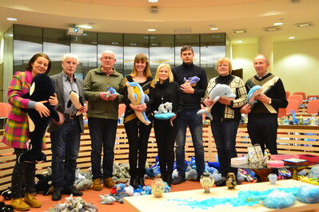
Guidance for completing this form

The verification of collection records relies heavily on an organised, detailed and thorough inventory.
- Make sure when filling out the table to use logical item names and descriptions.
- Photos must be clear and matched to the correct video reference.
- Items that look similar should be listed next to one another, with distinguishing features highlighted
in the description, photo and video. This will prevent items from being discounted as duplicates.
The largest collection of dolphin-related items is 3,516 achieved by Ausra Saltenyte (Lithuania) in Vilnius, Lithuania, on 31 January 2019.
- Key assessments made by the specialist witness can be noted in the description column.

Example of completed form: Largest collection of dolphin-related items

No. | Item Name | Description | Image reference | Video reference | Image
1 | Dolphin pot 36 | Metal pot with a dolphin breaching out of the water. | 1264_pot_36.jpg | 1:22:45 | 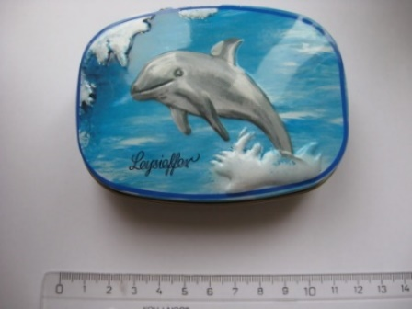
2 | Dolphin pot 37 | Material-covered dolphin pot, depicting an underwater scene. Two dolphins on one side, five on the reverse side.  Marine biologist specialists witness included this in the final count as it predominantly features dolphins – seven in total, compared to two fish. | 1265_pot_37.jpg | 1:23:12 | 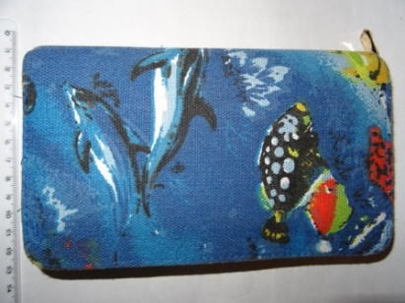
3 | Dolphin plushie 1 | Simple design plushie in soft velvet. | 1266_plushie_1.jpg | 1:23:35 | 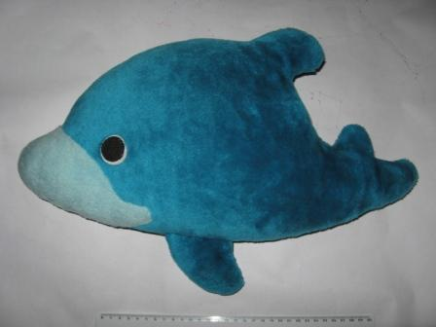

My record application

Claimant name(s):
Record title applied for:

No. | Item Name | Description | Image reference | Video reference | Image
 | The name of the item | A brief description of the item | The file name for the image | The time mark of where the object appears in the video | A copy of the image
1
2
3
4
5
6
7
8
9
10
11
12
13
14
15
16
17
18
19
20
21
22
23
24
25

To add more rows to this table, please right click on the final row and select ‘Insert’, ‘Insert Rows Below’.

